Resume

Vishal sharma
1, Aradhana parisar, Ujjain, India
Phone: 8861355004
Email: vishalsharma251284@gmail.com
Career Objective:
Looking for a Python programmer position with a company where my skills can be used in designing, securing, and optimizing applications and their performance.
Summary of Skills:
- Certified python Developer from Brainbench certification test (U.S.A.)in expert level. License I.d.:- 13158889
- Certification in expert level python programming
- Skilled in developing applications in Python language for multiple platforms
- Excellent knowledge of BS4,Feedparser,Mechanize,python2.7.11,python3.4,pandas,numphy,selenium ,matplotlib,xml ET, I/O,DATA analysis, manipulating,Data Preparation, SAX,Django ....etc
- Skilled in web scraping:-identification of source code,
- Proven ability to handle complex issues
- Exceptional analytical and quantitative skills
- Expertise in web scraping projects
- Build several software for web scraping
- User tracers and solve complex problems
- Provide inputs in planning and product processes
- Mentor fresher’s and develop their coding skills
Work Experience:
Python Programmer:-
Exilant Technologies:-As an independent contractor for Apple Inc.
25july-present
Client:-Apple Inc:
Project name:-Apple music personalization
Duration:- 2 month
Project Name:-Appstore –music framework:-
Duration:-currently in progress(last phase)
Software:-python 2.7.10,inbuilt modules.
Process perform:-Complete ETL process(jsonData)
VKStech(freelancer)
July 2011 – july2016
Profile Info:-LinkedIn:- https://in.linkedin.com/in/vishal-sharma-330b3190
Github:- https://github.com/vishalsharma123/
Brainbench(USA):-Expert level, python 3.4 Certificate:- http://www.brainbench.com/transcript.jsp?pid=13158889.
Upwork TestCentre:-I am in Top 30%("you can also check my profile on upwork")
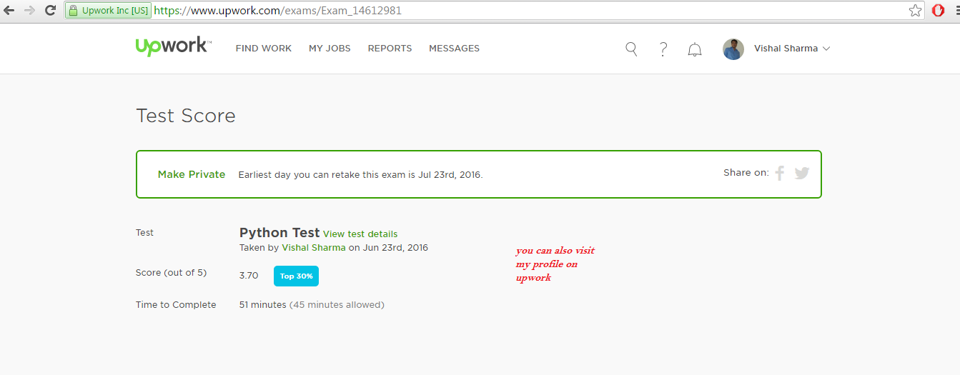

Education:
- B.pharma,post graduate in clinical data management
JCL pune(M.H.)
2011
Complex Projects:-
Project1:-Amazon scraper(windows)
Client:-Tom Friend
Fixed Rate:-300$/per month
Payment mode:-PayPal and up work
Status:-Working
Description:-scrapping product details like (ASIN, UPC, reviews, Product image etc)
Software:-python2.7, BS4 connector import.io, proxy server script
Project2:-yelp and yellow pages(Linux)
Client:- Britney Sayers (USA)
Payment mode:-PayPal
Fixed Rate:-400$
status:-completed
Description:-generate list related with doctors and medicinal industries in usa
Software:-using my own software build in python2.7, bs4, selenium, XML pr. ET
Project3:-manta(Linux) hourly Rate:-12$/hr
status:-Working
payment mode :-Direct
Client :-Sanjeev thakur(INDIA)
Description:-data of real estate company in usa
Software:-mechanize with network request,XML parsing along with python2.7
Project4:-edgarfiling(Linux)
Client:-Beatrices(Netherland)
Payment mode:-Upwork and PayPal
Fixed Price:-250$
status:-Completed
Description:-data related with tax payers
Software:-python2.7, bs4,XML parsing
Project5:-Trustpoilt(windows)
Client :-Sanjeev thakur(INDIA)
Payment mode:-PayPal and up work
Fixed Price:-800$
status:-working
Description:-fetching complete site,xml site urls from sitemap.
Software:-python, feedparser, requests, selenium,xml ET
Project6:-Build desktop application for bulk data manipulating, organising.(windows)

This software also used for scrape those site which having high security concern like linkedin, manta etc
Software:-own program in python.numpy, panda, libfile, bs4
Currently working on it and i will launch this software in market very soon
project 7:- Web scraping whois data(Linux)
Client:-Ted McDonald (U.S.A)
Payment mode:-Upwork
Hourl Price:-14$/hr
status:working
Description:-fetching complete Domain status, Registrant information,
Software:-python2.7, BS4 connector, proxy server script ,OCR ,PIL ,XML parsing
Project 8:- Need database scraper(windows)
Client :-Sanjeev thakur(INDIA)
Payment mode:-PayPal and up work
Fixed Price:-1000$
status:-working

Details:-
Need database scraper who can extract the data from any site.
- Project or Ongoing work: One-time project
- Other Skills: Data mining Data scraping Python Web Crawler Web scraping



Project 9:- Amazon Product Data Project(linux)

Details
I need a web scraping tool that can:
1. Scrape ASIN/UPC details from Amazon.com when I input a list/file of product names
2. Scrape a webstore for product details: Name, UPC, Price
I would prefer to be able to use this tool ongoing rather than just for a single use
